**UNIVERSITY OF BATANGAS – LIPA CAMPUS**

**COLLEGE OF ENGINEERING AND ARCHITECTURE**

**COMPUTER ENGINEERING**

DC and Servo Motors

**Experiment #6**

MICROPROCESSOR SYSTEMS

NAME: CASTILLO, JOAQUIN IVERSON M.

TIAMSIM, EDSEL

LASAT, PAULO

STUDENT NUMBER: 2020759

DATE OF SUBMISSION:

May 13, 2023

Engr. Charles Juanillas

PROFESSOR

**Discussion:**

In this next experiment, there will be different types of electrical motors to be used. These are DC motors and servo motors. DC Motors are continuous actuators that converts electrical energy into mechanical energy. The DC motor achieves this by producing a continuous angular rotation that can be used to rotate pumps, fans, compressors, wheels, etc.

The **DC Motor** or **Direct Current Motor** is most commonly used actuator for producing continuous movement and whose speed of rotation can easily be controlled, making them ideal for use in applications were speed control, servo type control, and/or positioning is required. A

DC motor consists of two parts, a “Stator” which is the stationary part and a “Rotor” which is the rotating part. The result is that there are basically three types of DC Motor available.

**Brushed Motors** are types of motors that produces a magnetic field in a wound rotor (the part that rotates) by passing an electrical current through a commutator and carbon brush assembly. The stators magnetic field is produced by using either a wound stator field winding or by permanent magnets.

**Brushless Motors** are types of motors that produces a magnetic field in the rotor by using permanent magnets attached to it and commutation is achieved electronically. They are generally smaller but more expensive than conventional brushed type DC motors because they use “Hall effect” switches in the stator to produce the required stator field rotational sequence but they have better torque/speed characteristics, are more efficient and have a longer operating life than equivalent brushed types.

**Servo Motors** are the brushed DC motors with some form of positional feedback control connected to the rotor shaft. They are connected to and controlled by a PWM type controller and are mainly used in positional control systems and radio-controlled models.

**Objectives:**

At the end of this laboratory exercise, you should be able to:

1. Control the DC Motors and Servo Motors
2. Manage the speed and direction using Arduino

**Equipment and Materials:**

The following equipment and materials are needed in performing this laboratory exercise:

1 – DC Supply (5V-12V Output)

1 – Breadboard

1 – ARDUINO UNO

4 – 47-ohm to 500-ohm ¼W resistor

1 – Servo Motor

1 – DC Motor

1 – NPN 2n222a Transistor

1 – DC Motor

1 – Servo Motor

Set of Connecting Wires

**Procedure:**

1. Prepare Arduino, breadboard, DC Motor, Servo Motor, 2n222a transistors, 9V power supply and set of connecting wires.

1. Based on the figure below, follow the connection of the DC motor and the Arduino.

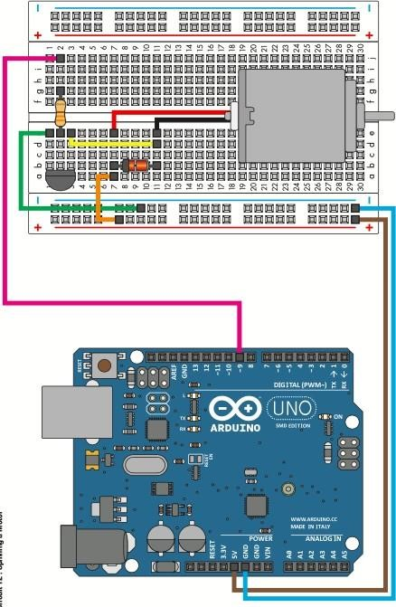

1. The transistor acts like a switch, controlling the power of the motor. Arduino pin 9 is used to turn the transistor on/off. Values from 0 – 255 will determine the speed of the DC motor.

Arduino pin 9 is a PWM pin.

1. Create an Arduino program that will turn the DC motor in maximum rpm for 5 seconds and turn in the slowest rpm after 5 seconds.
2. Replace the DC motor into a servo motor. Instead of fastest and slowest rpm, create an Arduino program that will turn the servo motor to its longest left after 5 seconds, and turn to its longest right after 5 seconds.

**Activity Questions:**

1. What is PWM? How does it control the speed/direction of the motors?
2. How does the voltage value affect the motors?

**Procedure:**

1. Prepare Arduino, breadboard, DC Motor, Servo Motor, 2n222a transistors, 9V power supply and set of connecting wires.

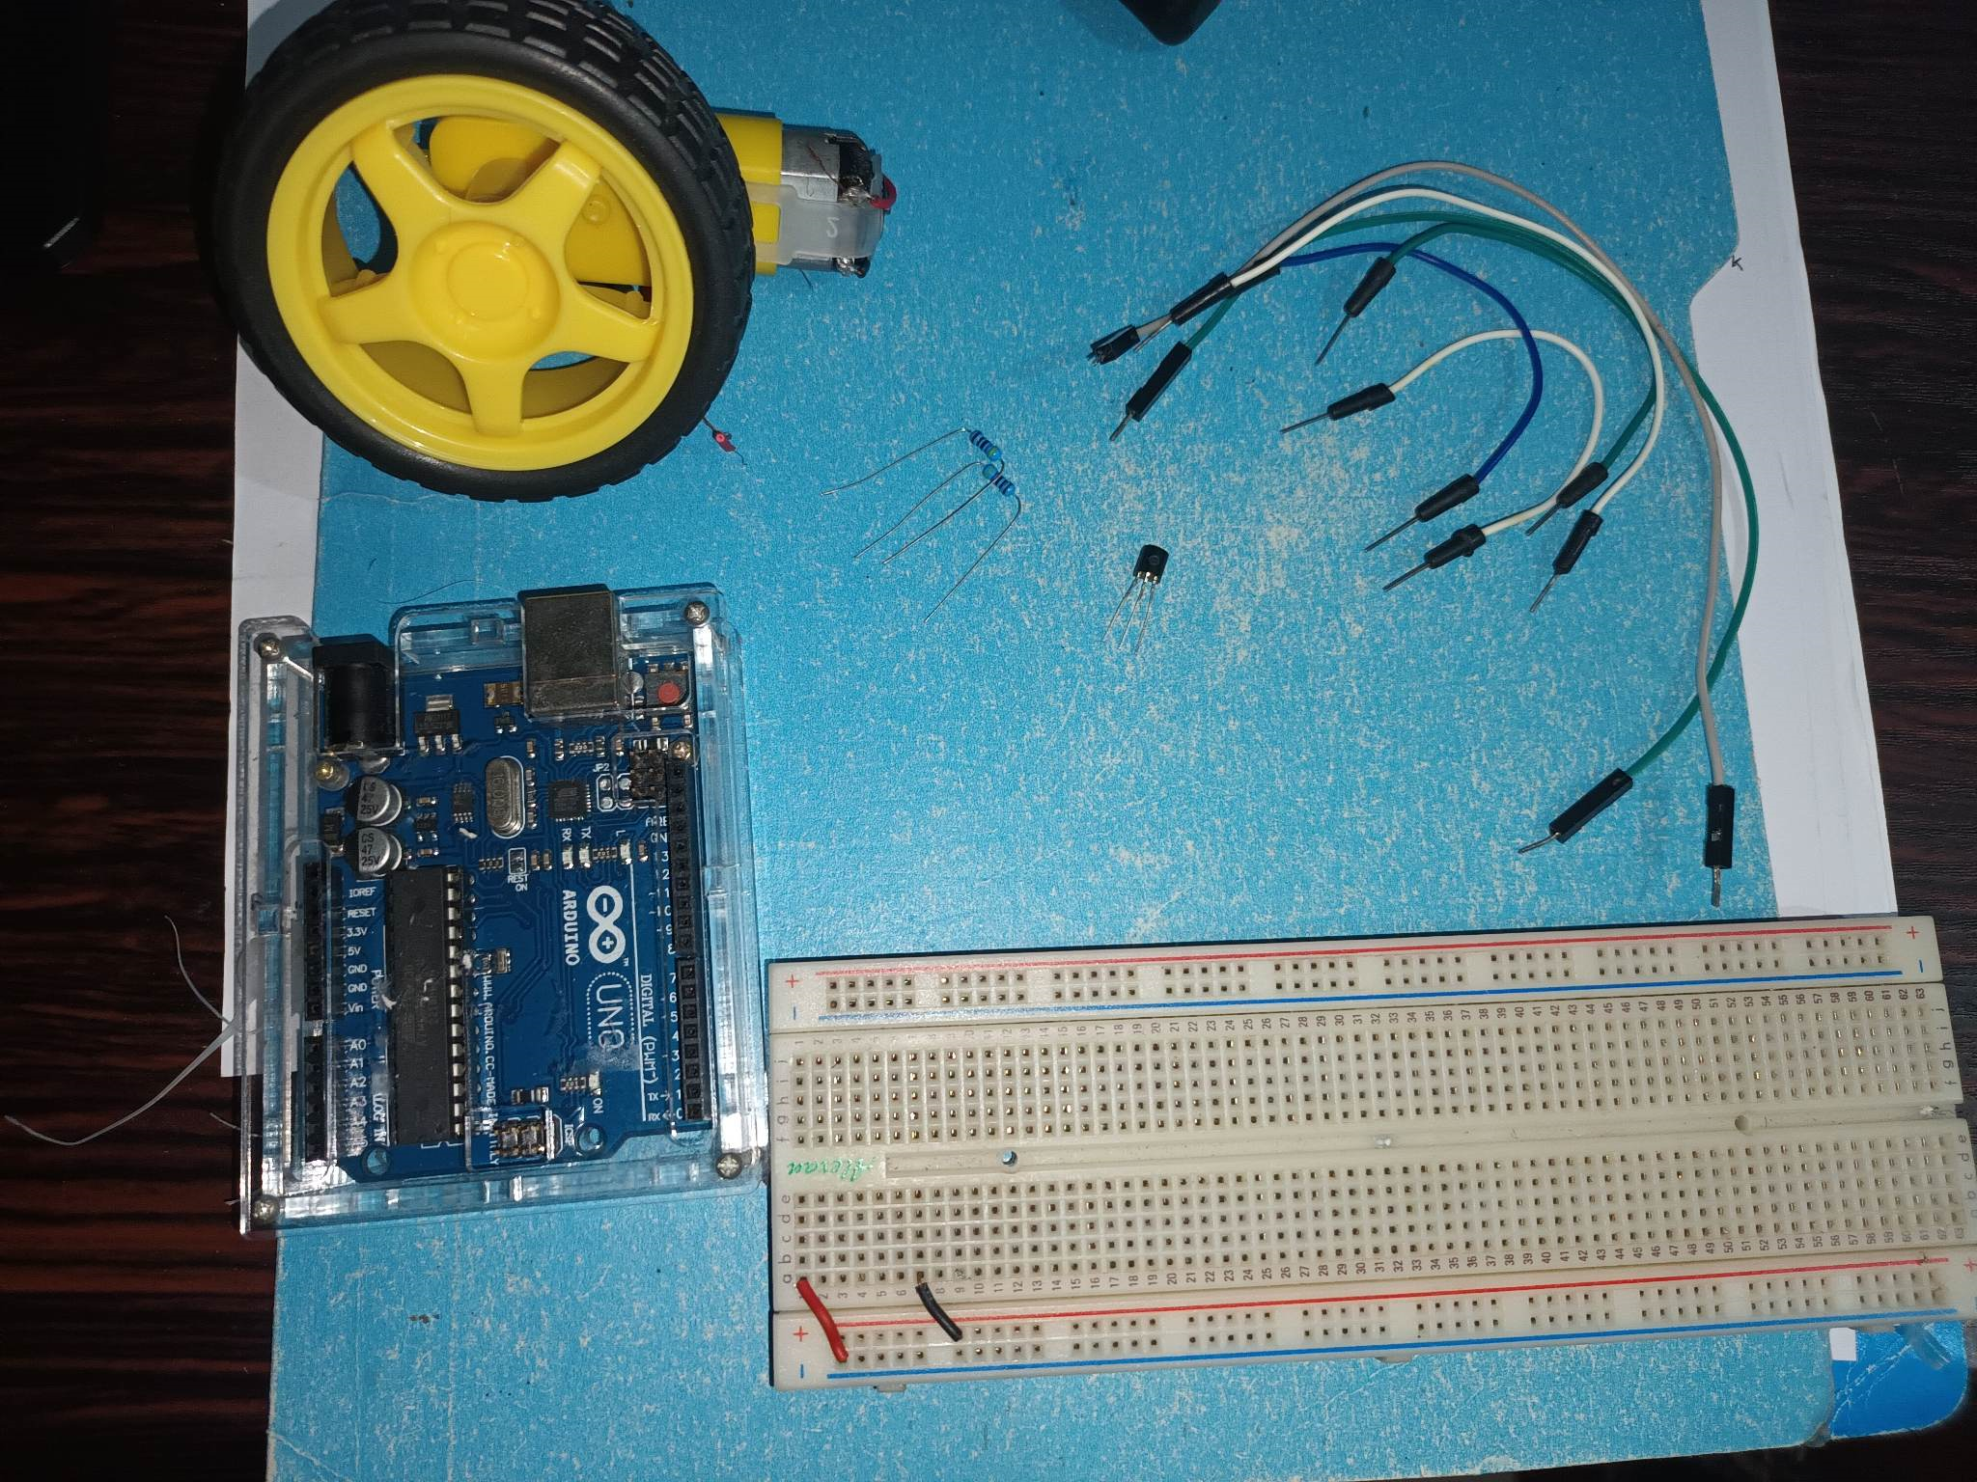

1. Based on the figure below, follow the connection of the DC motor and the Arduino.

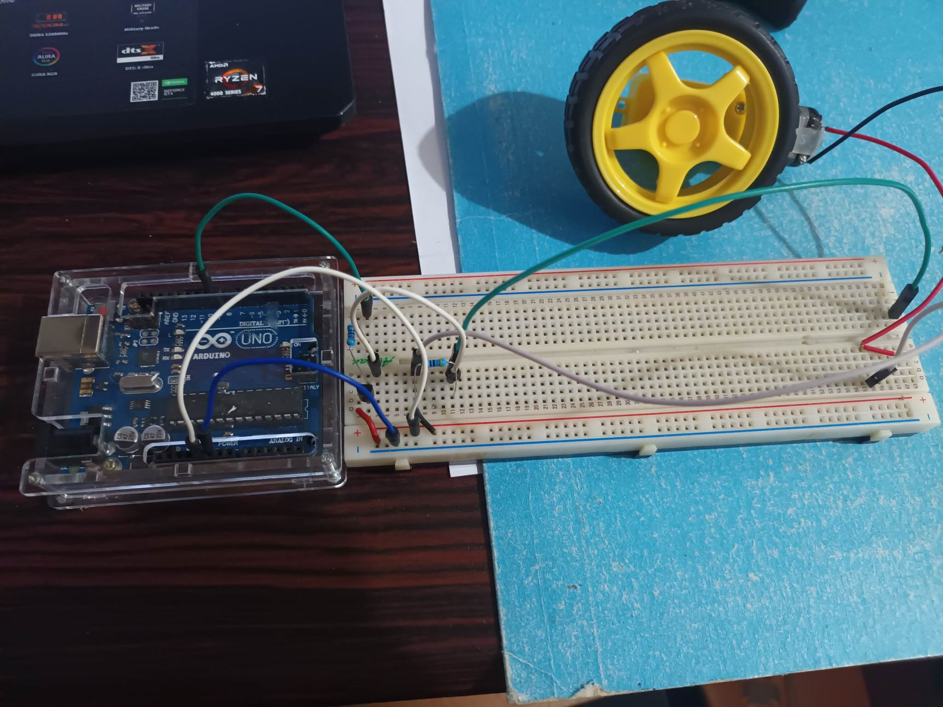

1. The transistor acts like a switch, controlling the power of the motor. Arduino pin 9 is used to turn the transistor on/off. Values from 0 – 255 will determine the speed of the DC motor.

Arduino pin 9 is a PWM pin.

1. Create an Arduino program that will turn the DC motor in maximum rpm for 5 seconds and turn in the slowest rpm after 5 seconds.

<https://drive.google.com/drive/folders/1TYxkfdhF2R0Rj--9sRBfAmgC81gm1xhB?fbclid=IwAR3f9SAtpRN424DMOR-cMUAUEHbFuS-8qP3Dy_JolVabKbcNDPowObdrbyA>

//Castillo, Joaquin Iverson M.

const int motorPin = 9; // Pin connected to the base of the transistor

const int maxSpeed = 255; // Maximum motor speed (0-255)

const int minSpeed = 0; // Slowest motor speed (0-255)

const int duration = 10000; // Duration of each speed (in milliseconds)

void setup() {

pinMode(motorPin, OUTPUT);

}

void loop() {

// Rotate at maximum speed for 10 seconds

motorSpeed(maxSpeed);

delay(duration);

// Reduce speed for 3 seconds

motorSpeed(minSpeed);

delay(3000);

}

void motorSpeed(int speed) {

analogWrite(motorPin, speed);

}

5. Replace the DC motor into a servo motor. Instead of fastest and slowest rpm, create an Arduino program that will turn the servo motor to its longest left after 5 seconds, and turn to its longest right after 5 seconds.

<https://drive.google.com/drive/folders/1TYxkfdhF2R0Rj--9sRBfAmgC81gm1xhB?fbclid=IwAR3f9SAtpRN424DMOR-cMUAUEHbFuS-8qP3Dy_JolVabKbcNDPowObdrbyA>

**Activity Questions:**

1. **What is PWM? How does it control the speed/direction of the motors?**

Pulse Width Modulation (PWM) is a commonly used technique for microcontroller-based control of DC motors. By rapidly switching the power on and off, we can make the motor run at a speed that is midway between zero and maximum. This is achieved by using a PWM controller, which generates a series of pulses to turn the motor on and off. By adjusting the width of these pulses, we can control the speed of the motor. PWM allows us to modulate the width of the pulses to regulate the motor speed effectively.

1. **How does the voltage value affect the motors?**

The speed of an electric motor is determined by the voltage applied to it. When the voltage is increased, the electric motor rotates at a higher speed.

**Results and Discussion:**

**Conclusion:**

In this project, we will utilize Pulse Width Modulation (PWM) to control the speed of a DC motor by adjusting the width of the pulse applied to the motor. For instance, servo motors typically consist of three wires, power, ground, and signal. The power wire, usually red, connects to the Arduino board's 5V pin. The ground wire, commonly black or brown, is connected to one of the board's ground pins. The signal wire, typically yellow or orange, is linked to a PWM pin on the board. The signal line is employed to manage the servo motor by sending a series of pulses. The width of the pulse determines the angular position of the servo, with these types of servos typically capable of rotating up to 180 degrees within their physical limits of travel.

REFERENCES:

• https://arduino.cc